Practical - 7
Practical Title: PHP Form Processing with Server-Side Validation and CSV/JSON File Storage
Problem Definition: Process submitted registration/contact form data using PHP. Validate and sanitize inputs on the server side and store records in CSV or JSON file format. Display success/error messages.
Theory :
1. Is the form submitted using POST?
Yes. The form should use the POST method so that the submitted registration or contact data is sent to the PHP server for processing. PHP can access the submitted values using $_POST after the form is submitted.
2. Are inputs validated and sanitized server side?
Yes. Server-side validation checks whether the submitted values are present and follow the required format, such as a valid email address or non-empty name. Sanitization removes or encodes unwanted characters before the data is displayed or stored. Server-side checks are important because browser-side validation can be bypassed.
3. Is file writing handled safely?
Yes. File writing should be handled carefully by checking the data before storing it, using appropriate file functions, and opening the file with the required mode. For CSV storage, fputcsv() can be used to write fields safely. For JSON storage, json_encode() can convert the records into JSON before writing them to the file. File access should also be controlled so that unintended files are not overwritten.
4. Are success and error responses displayed clearly?
Yes. After processing the form, PHP should display a clear success message when the data is validated and stored successfully. If validation or file storage fails, an understandable error message should be displayed so the user knows what needs to be corrected.
Implementation/ Output/ Result
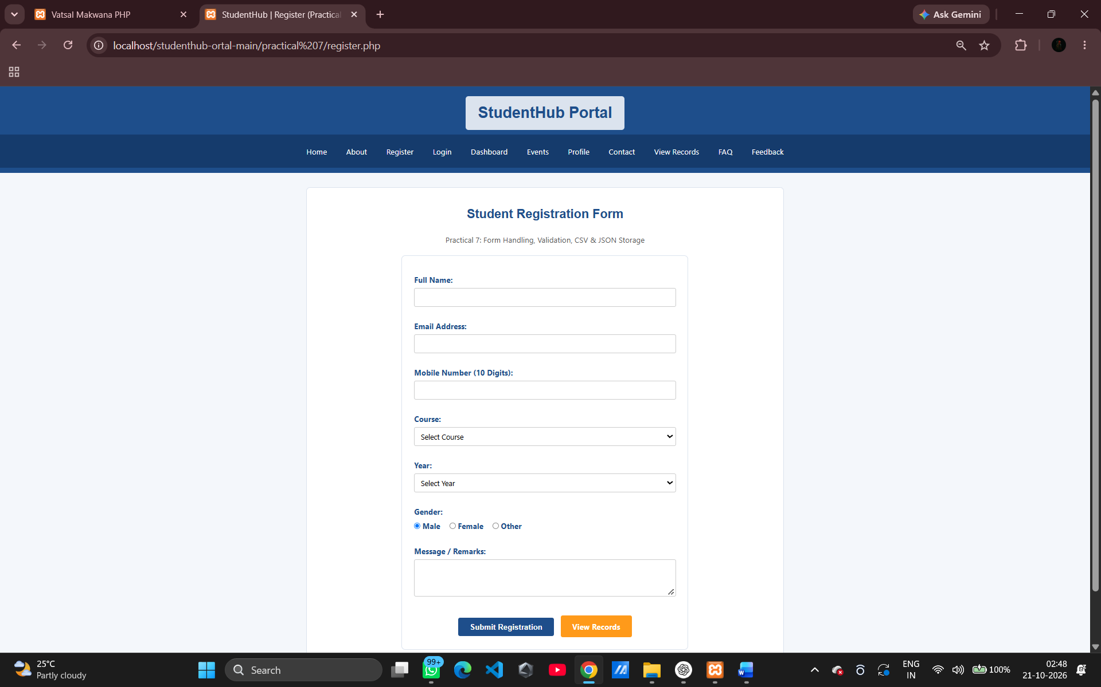
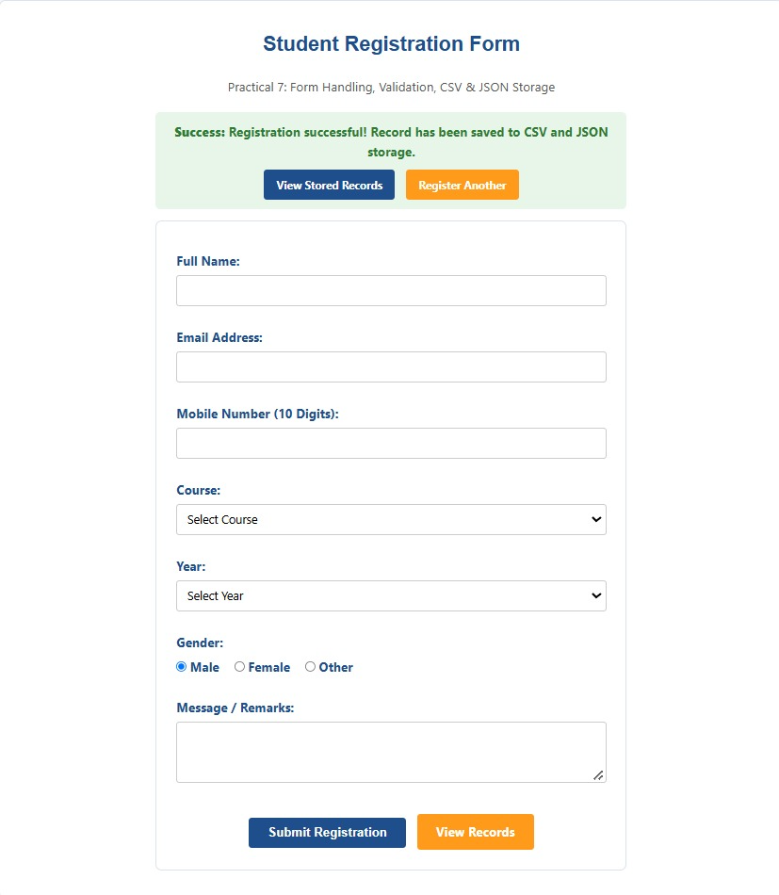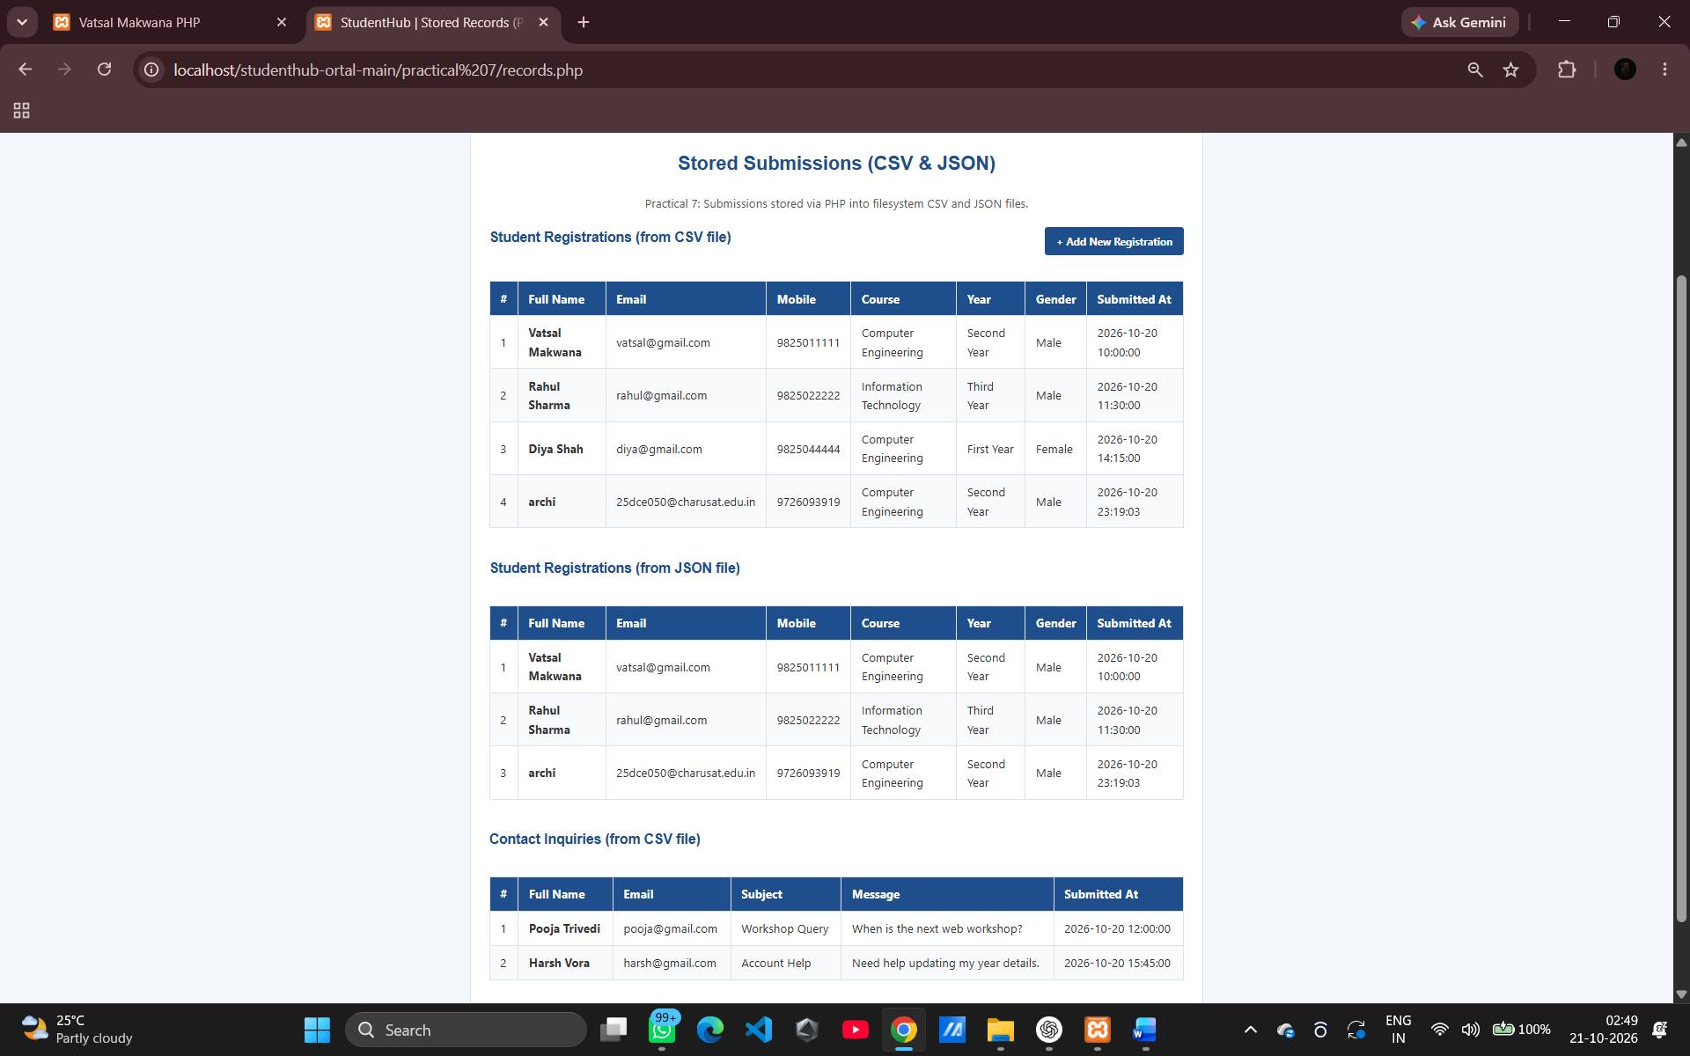

Department of Computer Engineering
25DCE009

GitHub Repository Link
https://github.com/archibhatt091601/studenthub-ortal

